**Objective Questions:**

1. **What is the distribution of account balances across different regions?**

* The distribution of account balance across different regions is shown in the below Column Chart. We can see how the sum of account balance for three regions is distributed.

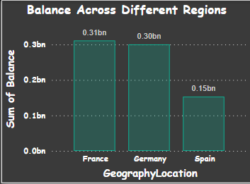

1. **Identify the top 5 customers with the highest Estimated Salary in the last quarter of the year. (SQL)**

* *We can Identify the top 5 customers with the highest estimated salary in the last quarter of the year by using the below shown query in the image.*

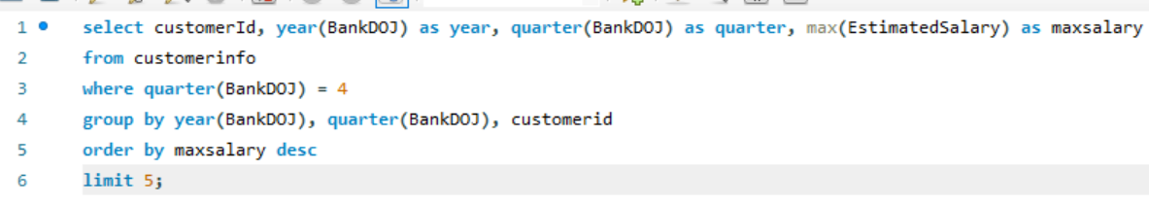

* *The output of the above-mentioned query is as below showing the highest estimated salary in the last quarter of the year.*

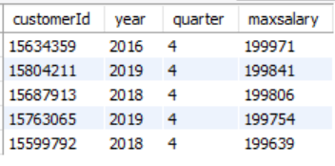

1. **Calculate the average number of products used by customers who have a credit card. (SQL)**

* *In HasCrCard 1 value indicate that the customer is the credit card holder, so to calculate the average number of products used by customers who have credit card is as below:*

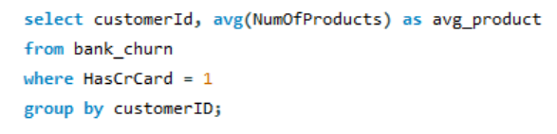

*The output of the above query will give us the average no. of products used by customers who have credit card which is shown below. (The result returned 7055 rows.)*

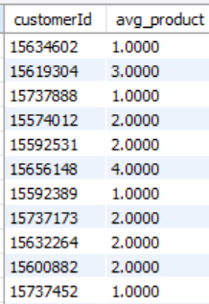

1. **Determine the churn rate by gender for the most recent year in the dataset.**

* *In order to find the churn rate by using SQL we have to use the join and write a query for churn rate by gender for the most recent year in the dataset which we can see in the below screenshot.*

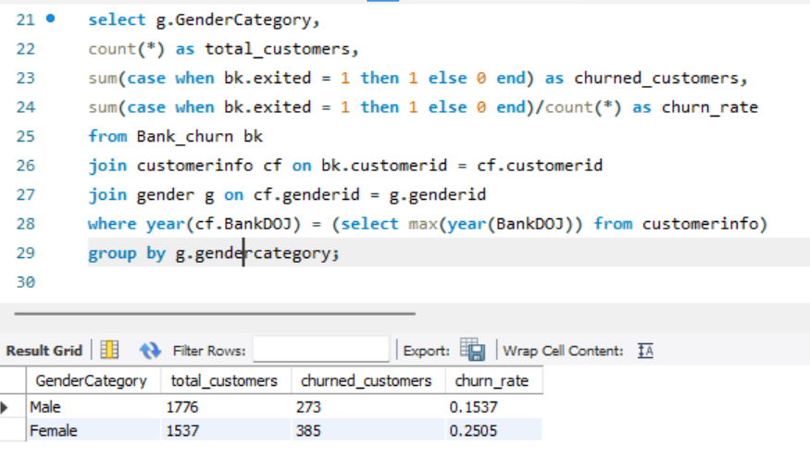

***The churn rate for the male is 0.1537 while the churn rate for the female is 0.2505***

1. **Compare the average credit score of customers who have exited and those who remain. (SQL)**

* The query to compare the average credit score of customers who have exited and those who remain is as follow.
* 0 indicate Retain and 1 indicate Exit

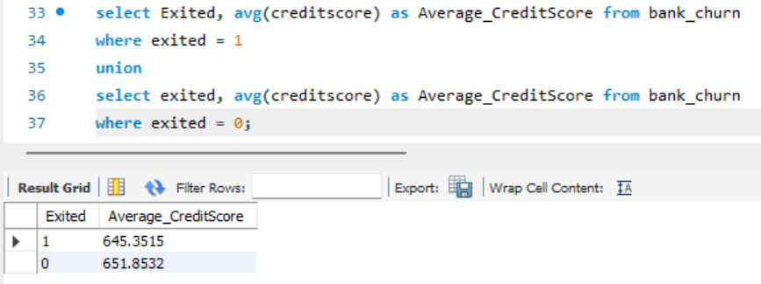

1. **Which gender has a higher average estimated salary, and how does it relate to the number of active accounts? (SQL)**

* Female has higher average estimated salary as compared to male while the active account of female is comparatively less than the male. We can see the same in the below query.

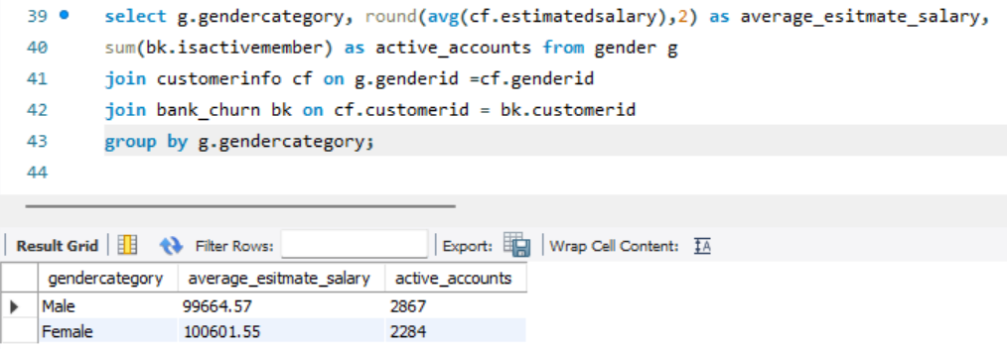

1. **Segment the customers based on their credit score and identify the segment with the highest exit rate. (SQL)**

* *In order to segment the customers based on their credit score we have to use case when query and we can solver the above as per the below query*

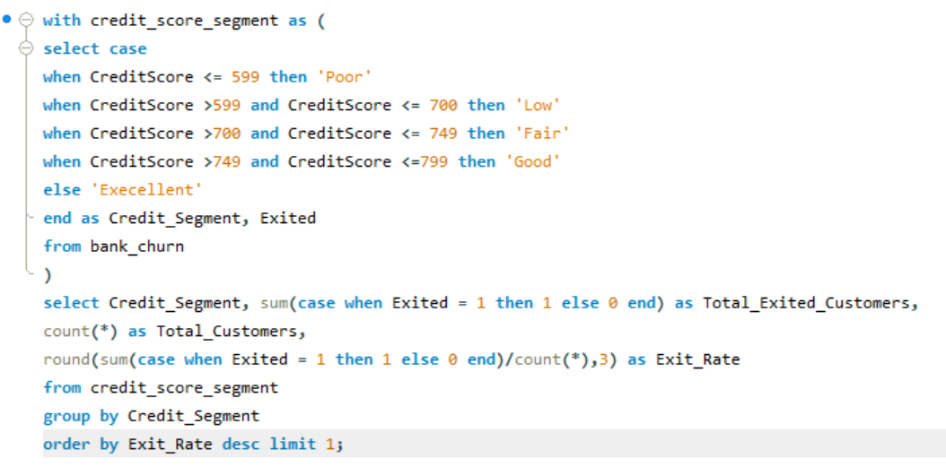

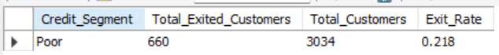

1. **Find out which geographic region has the highest number of active customers with a tenure greater than 5 years. (SQL)**

* As per the data, France has the highest number of active customers with a tenure greater than 5 years with **active customer 797.**

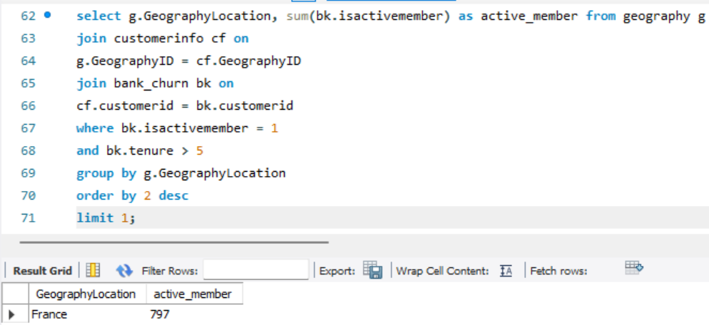

1. **What is the impact of having a credit card on customer churn, based on the available data?**

* As per the analysis perform on the data we can see that the churn rate for the customer having credit card is high as compared to non-credit card hold.

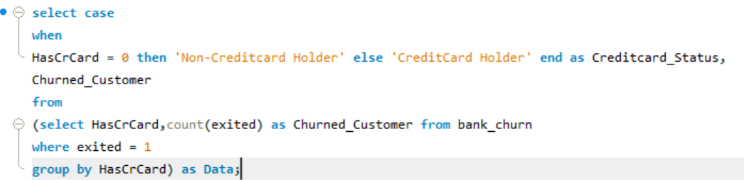

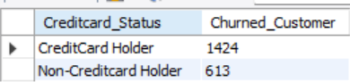

1. **For customers who have exited, what is the most common number of products they have used?**

* For customers who have exited, the most common number of products they have used is 1 which we can get by the below mentioned query

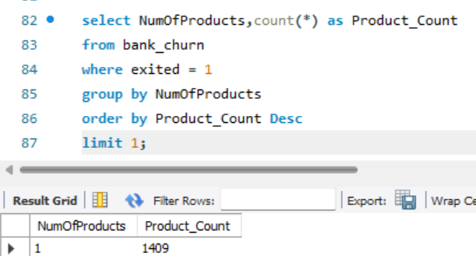

1. **Examine the trend of customers joining over time and identify any seasonal patterns (yearly or monthly). Prepare the data through SQL and then visualize it.**

* As per the below graph mentioned we can see that there is positive trend of customer joining over the time.
* By using the drilldown function in PowerBI we can see the joining of the customer is higher in the month of September, November and December in every year.

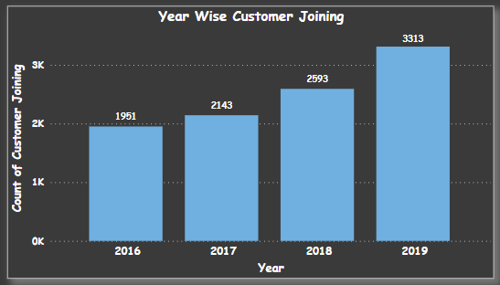

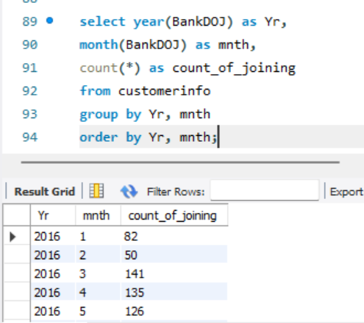

1. **Analyze the relationship between the number of products and the account balance for customers who have exited.**

* As you can observe in the above chart, customers who purchased 4 products have high average balance in their account compared to others.

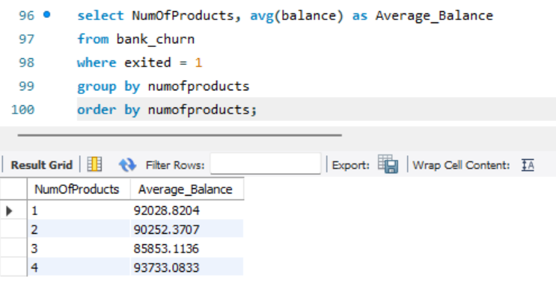

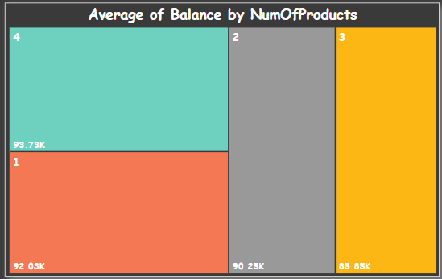

1. **Identify any potential outliers in terms of balance among customers who have remained with the bank.**

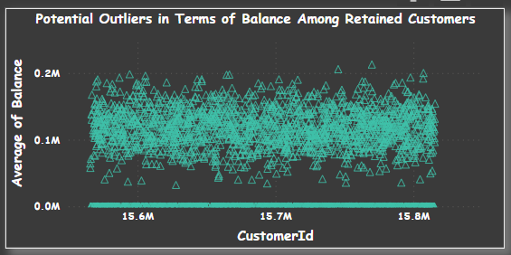

There are some high balance datasets and very low almost zero balance datasets in the above visual which are the outliers in terms of balance among customers who have remained with the bank.

1. **How many different tables are given in the dataset, out of these tables which table only consists of categorical variables?**

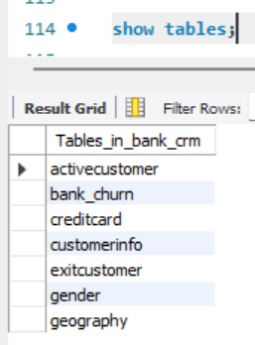

* Out of the above-mentioned table activecustomer, creditcard, exitcustomer, gender and geography table consist of categorical variable.

1. **Using SQL, write a query to find out the gender-wise average income of males and females in each geography id. Also, rank the gender according to the average value. (SQL)**

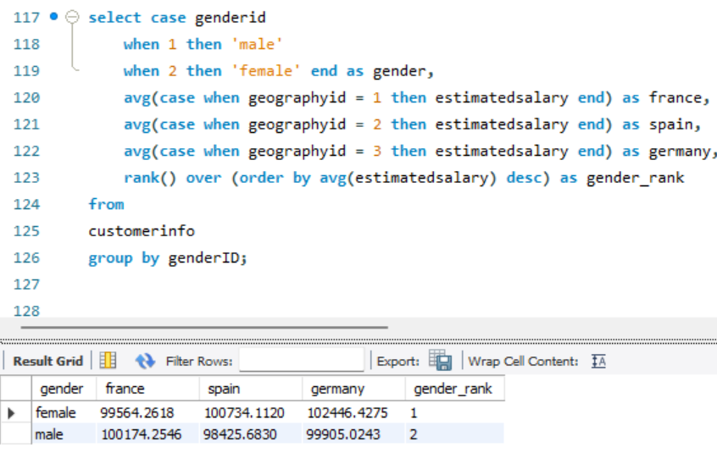

1. **Using SQL, write a query to find out the average tenure of the people who have exited in each age bracket (18-30, 30-50, 50+).**

* Below is the query to find out the average tenure of the people who have exited in each age bracket (18-30, 30-50, 50+)

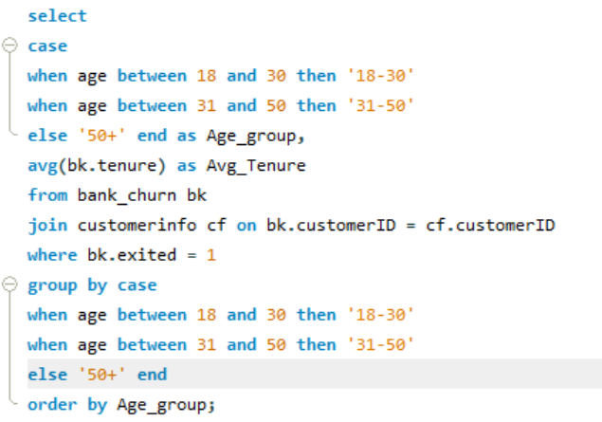

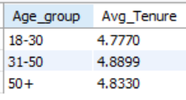

1. **Is there any direct correlation between salary and the balance of the customers? And is it different for people who have exited or not?**

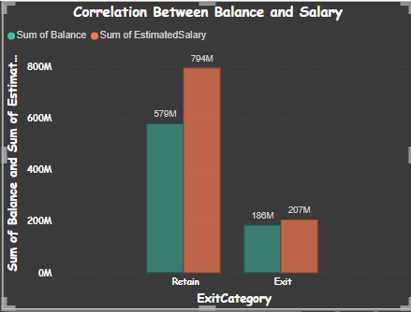

* Yes, there is direct correlation between salary and the balance of the customer which we can see in the above graph as the total salary increases the total balance also increased.
* Yes, the correlation between the exited customer’s salary and balance is highly correlated than the customer who retain with the bank.

1. **Is there any correlation between the salary and the Credit score of customers?**

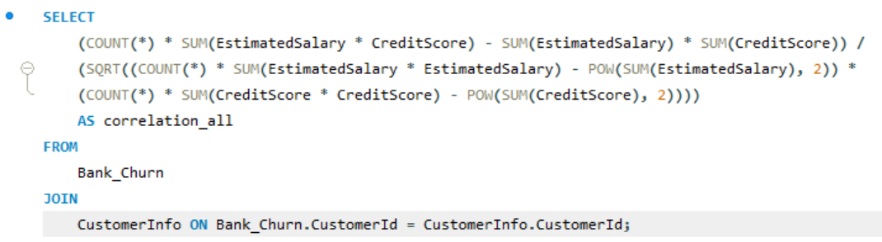

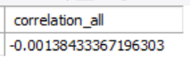

* From the above query we can say that there is almost no correlation between salary and the credit score of the customer.

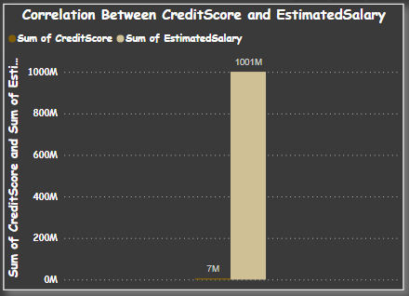

1. **Rank each bucket of credit score as per the number of customers who have churned the bank.**

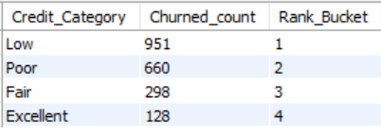

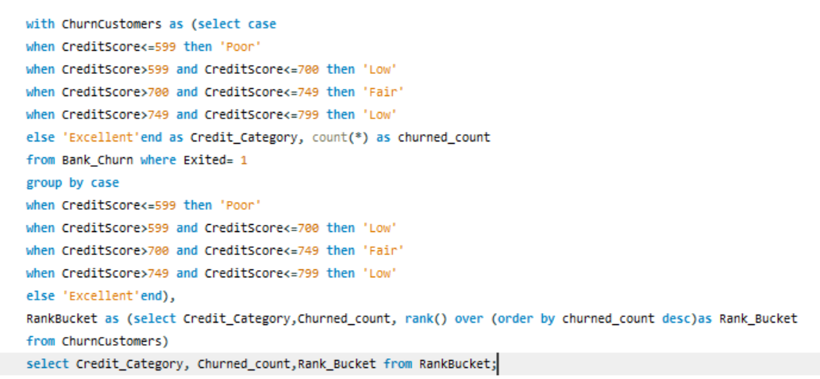

1. **According to the age buckets find the number of customers who have a credit card. Also retrieve those buckets that have lesser than average number of credit cards per bucket.**

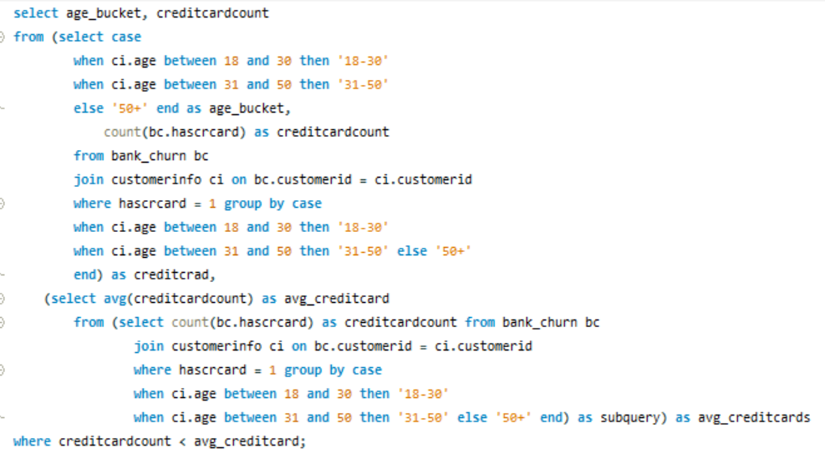

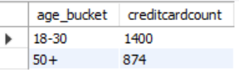

1. **Rank the Locations as per the number of people who have churned the bank and average balance of the customers.**

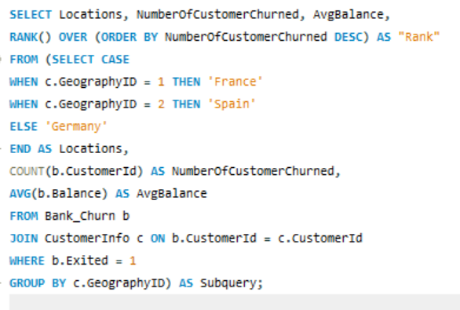

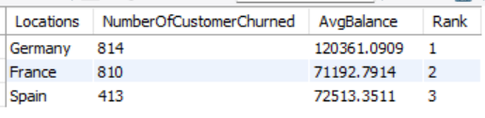

1. **As we can see that the “CustomerInfo” table has the CustomerID and Surname, now if we have to join it with a table where the primary key is also a combination of CustomerID and Surname, come up with a column where the format is “CustomerID_Surname”.**



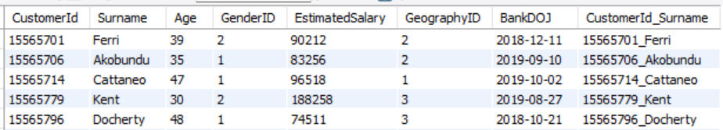

1. **Without using “Join”, can we get the “ExitCategory” from ExitCustomers table to Bank_Churn table? If yes do this using SQL.**

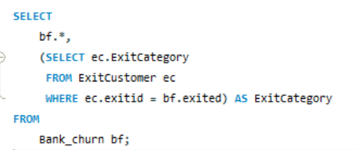

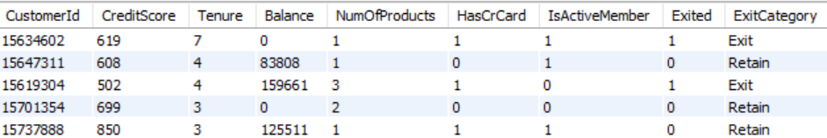

1. **Were there any missing values in the data, using which tool did you replace them and what are the ways to handle them?**

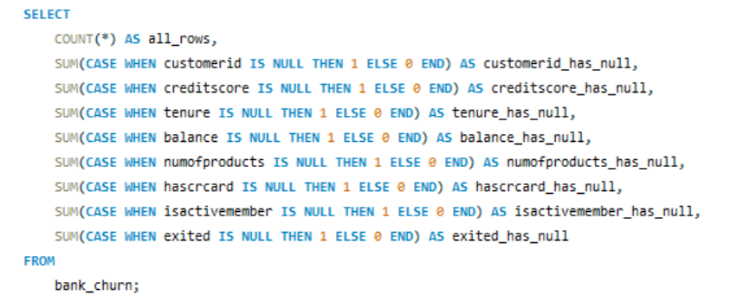



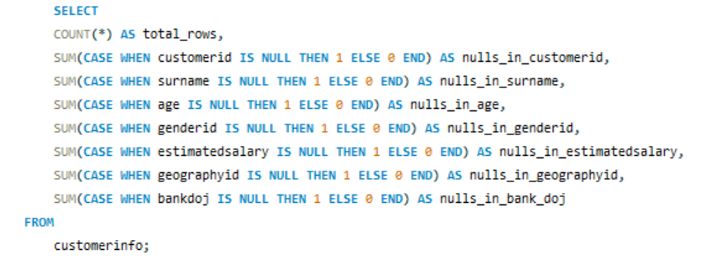



With the above SQL Query, we can check if there are any null values in the dataset. We can use COALESCE function to replace the null values with default value.

We can remove the rows with missing values using DELETE function of Data Manipulation Language (DML).

1. **Write the query to get the customer IDs, their last name, and whether they are active or not for the customers whose surname ends with “on”.**

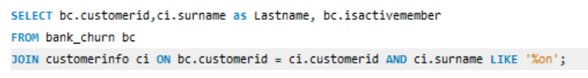

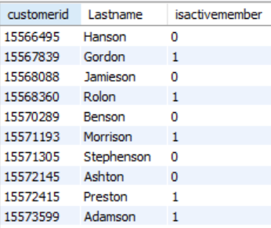

**Subjective Questions:**

1. **Customer Behaviour Analysis: What patterns can be observed in the spending habits of long-term customers compared to new customers, and what might these patterns suggest about customer loyalty?**

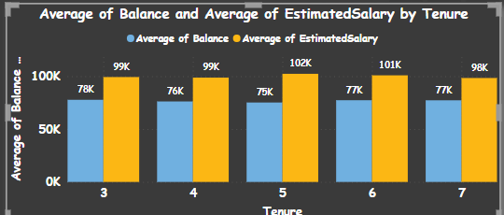

The average estimated salary and average balance offer insights into customer spending patterns, reflecting income levels and remaining account funds after expenses. Notably, there seems to be no discernible trend in spending habits between new and long-standing customers, as their account balances show comparable levels.

1. **Product Affinity Study: Which bank products or services are most commonly used together, and how might this influence cross-selling strategies?**

* The dataset lacks detailed information about individual products or their combinations, hindering the ability to analyze product affinity. Consequently, drawing insights or implementing cross-selling strategies based on this limited data is challenging.

1. **Geographic Market Trends: How do economic indicators in different geographic regions correlate with the number of active accounts and customer churn rates?**

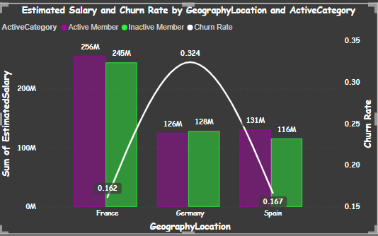

The chart reveals variations in churn rates across different geographic locations, with Germany exhibiting the highest churn rate compared to the other two countries. Notably, France demonstrates a higher sum of estimated salary as well as a greater number of active members when compared to the other countries.

1. **Risk Management Assessment: Based on customer profiles, which demographic segments appear to pose the highest financial risk to the bank, and why?**

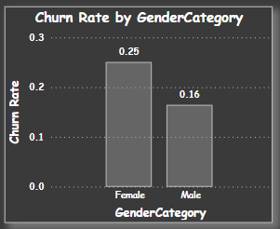

* Among our customer profiles, the gender category seems to present the greatest financial risk to the bank, with female customers exhibiting a significantly higher churn rate compared to male customers. The churn rate jumps by nearly 9% when transitioning from male to female customers.

1. **Customer Tenure Value Forecast: How would you use the available data to model and predict the lifetime (tenure) value in the bank of different customer segments?**

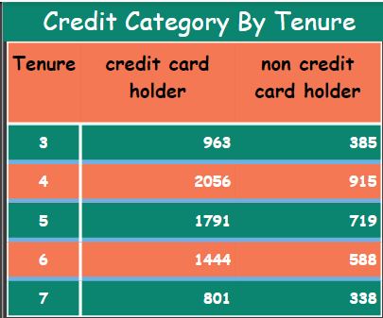

From the illustrated graph and the data provided, it's evident that customers who hold a credit card are a valuable asset in terms of generating interest income for the bank. They are likely to contribute higher revenue to the bank's coffers over time.

1. **Marketing Campaign Effectiveness: How could you assess the impact of marketing campaigns on customer retention and acquisition within the dataset? What extra information would you need to solve this?**

* To effectively assess the influence of marketing campaigns on both retaining existing customers and acquiring new ones, we need essential details such as the cost incurred for these campaigns, the churn rate following the campaigns, and the rate of acquisition before and after their implementation. While we can access churn rate data from our dataset, it's imperative to ascertain whether this churn rate reflects the period before or after the marketing campaigns were executed.

1. **Customer Exit Reasons Exploration: Can you identify common characteristics or trends among customers who have exited that could explain their reasons for leaving?**

* Relying solely on attributes like credit score and active membership status makes it difficult to pinpoint the specific reasons why customers leave the bank. While these attributes offer some insights into customer behavior, they don't directly explain churn.
* Customer churn is influenced by a myriad of factors, including satisfaction with products/services, experiences with customer service, competition, and external influences. To gain a comprehensive understanding of churn drivers and actionable insights, it's crucial to complement our dataset with additional sources like customer feedback, surveys, qualitative data, and thorough analysis of customer interactions.

1. **Are 'Tenure', 'NumOfProducts', 'IsActiveMember', and 'EstimatedSalary' important for predicting if a customer will leave the bank?**

* It's difficult to conclude whether customers are departing from the bank solely based on the given attributes. The dataset reveals that even customers who are active members and have been with the bank for an extended period have left. Furthermore, factors like the number of products and estimated salary don't offer clear explanations for customer churn.
* To make precise predictions about customer churn, it's essential to gather feedback from customers regarding why they are leaving. This feedback would enable us to assess whether these attributes truly hold substantial predictive power in determining customer churn.

1. **Utilize SQL queries to segment customers based on demographics and account details.**

* Objective inquiries involved employing SQL queries to divide customers into groups based on demographic characteristics and account particulars such as gender, age, and credit score. This segmentation enabled subsequent analysis of customer data.

1. **How can we create a conditional formatting setup to visually highlight customers at risk of churn and to evaluate the impact of credit card rewards on customer retention?**

* While we can apply conditional formatting to flag customers with a high likelihood of churning, it's not feasible to utilize conditional formatting on charts as we examine the causes of customer churn based on churn rates across different locations and genders. Moreover, crucial information such as credit card rewards, essential for assessing their influence on customer retention, is absent.

1. **What is the current churn rate per year and overall as well in the bank? Can you suggest some insights to the bank about which kind of customers are more likely to churn and what different strategies can be used to decrease the churn rate?**

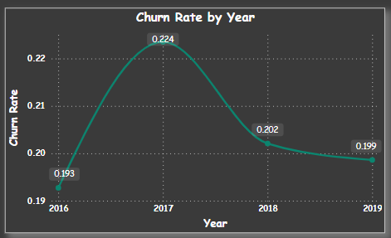

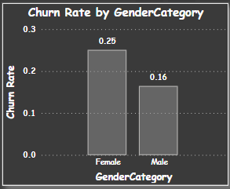

The provided image illustrates the churn rate per year, with an overall churn rate of 0.20 across the bank. From this data, it can be inferred that female customers exhibit a higher likelihood of churning, as they demonstrate a significantly elevated churn rate compared to male customers.

Tactics such as offering credit rewards for credit card usage, adjusting interest rates, or extending loan durations could be implemented as measures to retain customers within the bank.

1. **Create a dashboard incorporating all the KPIs and visualization-related metrics. Use a slicer in order to assist in selection in the dashboard.**

* I've developed a Power BI dashboard featuring key performance indicators (KPIs) and essential visuals. Additionally, I've incorporated slicers to facilitate easy selection within the dashboard.

1. **How would you approach this problem, if the objective and subjective questions weren't given?**

* By augmenting our dataset with additional information such as product specifics, interest income generated for the bank, and customer feedback, my intention is to evaluate customer worth effectively. This will enable us to devise strategies aimed at retaining high-value customers and mitigating churn. Through an in-depth examination of feedback provided by departing customers, we will identify shortcomings perceived within the bank and take targeted actions to rectify these issues, thereby enhancing our retention efforts.

1. **In the “Bank_Churn” table how can you modify the name of the “HasCrCard” column to “Has_creditcard”?**

* In Power BI, you can conveniently rename a column by simply right-clicking on the column name and selecting the "Rename" option.